This policy outlines the philosophy and approaches used in Attenborough School to strive to achieve depth and mastery in learning for all pupils.
Definition of mastery
The term ‘mastery’ learning in Attenborough School describes a depth of learning where pupils have not only understood a concept but can also use and apply it across a range of different contexts. Our definition of ‘mastery’ learning has been formed from information in documents such as the ‘Final report of the Commission on Assessment without levels’ document and NCETM materials.

At Attenborough School, mastery and greater depth is defined in terms of pedagogy as an approach which enables all pupils to reach the expected standard for their year group through the model of using both corrective and deepening activities as demonstrated by the mastery learning model.(Fig1)
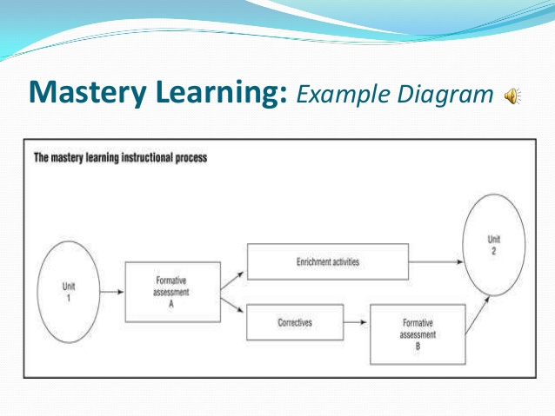
Fig 1
The aspiration is that all pupils should achieve a deep level of learning and that some will go beyond this expectation to achieve even greater depth. This deep level of learning will ensure that pupils have a strong grasp of content and can demonstrate this in a variety of ways. This deep learning may be demonstrated through:
- Fluency and independent application of concepts
- Being able to apply the skills in new contexts
- Synthesising information
- Creating new ideas using learnt information
- Explaining the information in their own words or to another audience
- Recall of the information across other work

Planning for mastery learning in Attenborough School
When planning opportunities, teachers will ensure that there are high expectations of all learners to achieve the objective. All pupils should have access to the initial teaching material and then further teaching and learning led through corrective tasks or deeper learning opportunities.

English

Writing:
At Attenborough School, mastery learning is planned for using a model of fewer genres over a greater length of time through the “Talk for Writing” process. Similar genres are blocked in order to ensure that punctuation, grammar and vocabulary skills can be taught and embedded, enabling pupils to achieve mastery within their writing and be able to transfer these skills across other future pieces. As far as possible, these genres will also be carefully linked to topic work to enable pupils to further transfer and embed skills within other subjects.
Teachers will ensure that high expectations of spelling, grammar and punctuation transference are placed on children’s work across all subjects. These skills will also be taken into consideration when deciding whether pupils should be assessed as having reached the expected standard.

Reading:
KS1 – pupils take part in regular guided reading sessions which will work on developing both word reading skills and comprehension and deepening understanding of texts. In addition to this, pupils will have access to a range of reading materials through using the school library and topic work and will experience regular story reading sessions with the teacher. They will be encouraged to transfer reading skills across the curriculum.
KS2 – teachers will plan for a range of activities across the week. These will include: One whole class reading session where pupils will be taught skills to enable them to develop their understanding of texts; weekly visits to the school library and regular access to a class reading book. In addition to this opportunities to transfer skills across the curriculum will be planned for.

Maths:
Teachers will plan units of work around the objectives for their year group and will block units of work to prevent surface level learning. The approach will follow the model of: assessing current learning skills; teaching new information; corrective/deeper learning opportunities leading to all learners achieving a deep understanding. All pupils should have opportunities to reason about maths, even at the beginning stages of a topic.

Pedagogical approaches to deepening learning
Teachers may use a range of pedagogical approaches to deepening learning these include: Bloom’s taxonomy, solo taxonomy and the concrete, pictorial, abstract approach to learning.

Standardisation
Regular standardisation meetings will be held as part of ongoing staff CPD in order to ensure a common understanding and interpretation of standards. These meetings will run across all three areas of maths, writing and reading. In addition to standardisation meetings, regular monitoring activities will also take place to identify strengths of the school and further areas for CPD.

Assessment for mastery
For the school’s approaches to assessing mastery and deeper learning see assessment policy

